Кунедилов Бахытжан ИС-202/2

Практическая работа 1

Задание 1

<DOCTYPE html>

<html>

<head>

<meta charset="UTF-8"/>

<style>

span {

color: springgreen;

font-size: xx-small;

}

span.Mac {

color: tomato;

font-size: small;

}

p{

color: blueviolet;

font-size: x-large;

}

</style>

</head>

<body>

<img src="Steve.jpg" height="200px">

<h3> ТЕКСТ В ФОРМЕ H3 </h3>

<p> Привет, я Стив. <span class="Mac"> Давай копатьв шахте.</span><span>Найдем алмазы и сделаем алмазные доспехи.</span></p>

<select id="Цвет">

<option value="Mar">Maroon</option>

<option value="Gre">Green</option>

<option value="Yel">Yellow</option>

<option value="Blu">Blue</option>

<option value="Red">Red</option>

</select>

<p><input type="submit" value="Применить"></p>

<p>Ваше имя: <input type="text" size="40"></p>

<p>Ваше фамилия: <input type="text" size="40"></p>

<p>Введите пароль: <input type="text" size="40"></p>

</body>

</html>

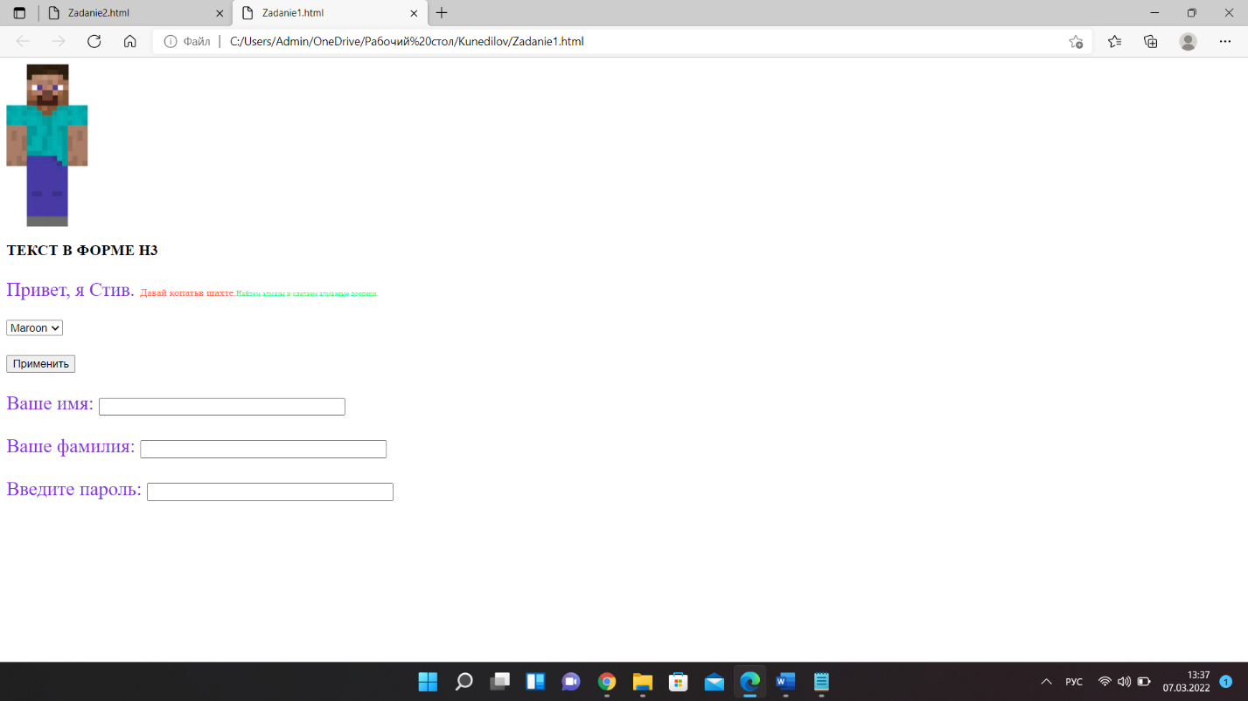

Задание 2

<DOCTYPE html>

<html>

<head>

<meta charset="UTF-8"/>

<style>

p {

font-size: x-large;

}

</style>

</head>

<body>

<h1>Форма Регистрации</h1>

<p>Ваше имя <input type="text" size="40"></p>

<p>Ваше фамилия <input type="text" size="40"></p>

<p>E-mail <input type="text" size="40"></p>

<p>Пароль <input type="text" size="40"></p>

</body>

</html>

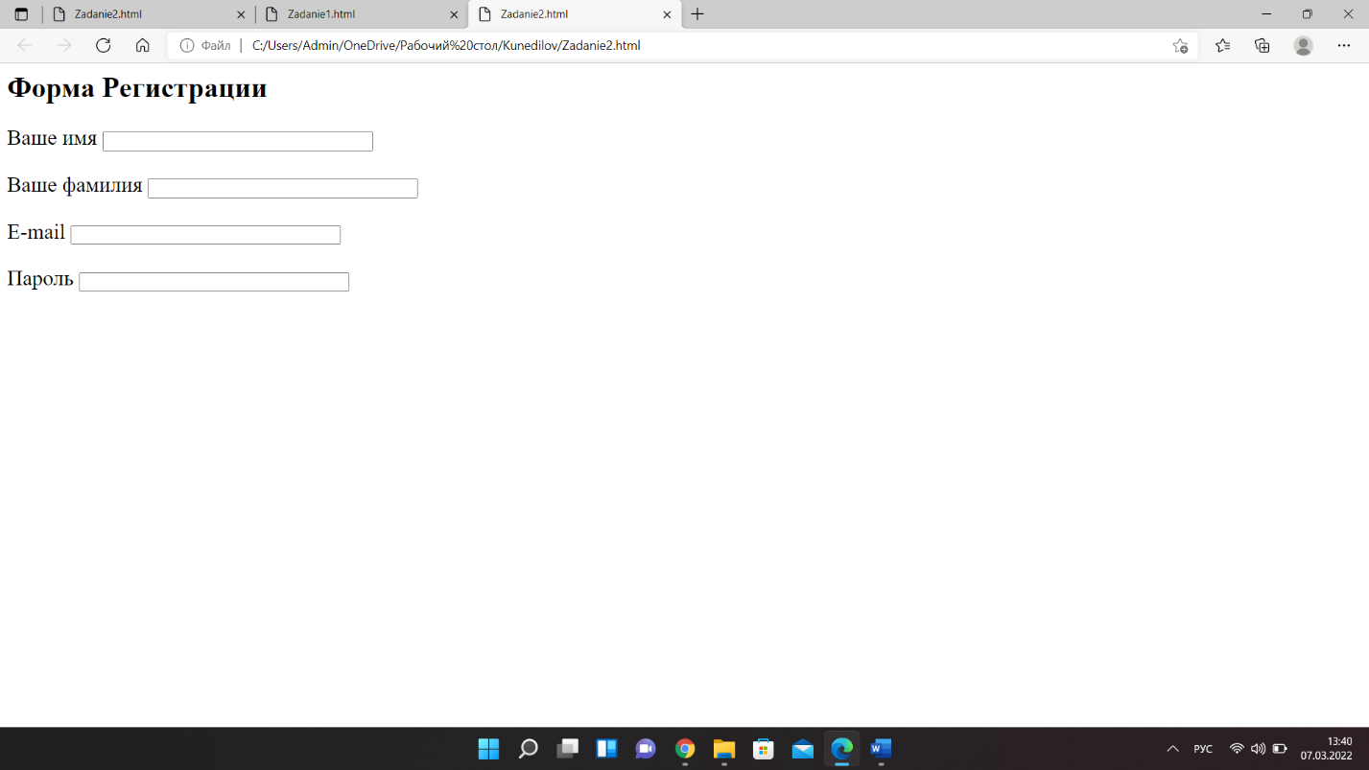

Задание 3

<DOCTYPE html>

<html>

<head>

<meta charset="UTF-8"/>

<title>2 Задания</title>

<style>

P.dline {

line-height: 0.1cm;

margin-left: 24;

}

</style>

</head>

<body>

<h1>Main Title</h1>

<div class="Search">

<label>Search <input type="text" required></label>

<input type="button" name="Кнопка" value="Submit">

</div>

<div class="123">

<div class="1"> <p class="dline">-<a href=""> Home</a></p></div>

<div class="2"> <p class="dline">-<a href=""> Profucts</a></p></div>

<div class="3"> <p class="dline">-<a href=""> About</a></p></div>

</div>

<b style="font-size: 25px">Main title</b>

<p style="font-size: 16px">This is the content of this section</p>

<p style="font-size: 14px">Copyrigth & copy: KazUTB 2022</p>

</body>

</html>

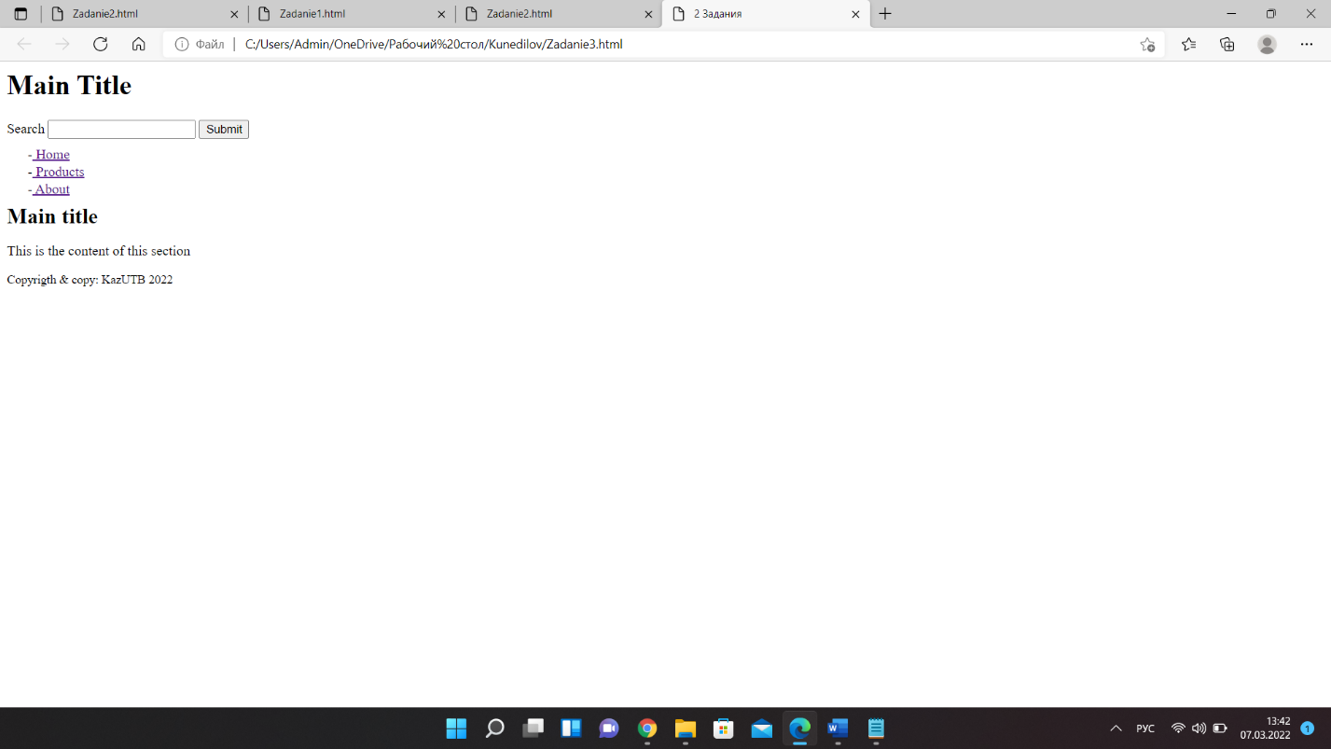

Задание 4

<DOCTYPE html>

<html>

<head>

<meta charset="UTF-8"/>

<title>4 задания</title>

<style>

li {

font-size: 20px;

}

.mac {

margin-left: 2%;

}

</style>

</head>

<body>

<li>Круги</li>

<div class="mac">

<img src="Circle.jpg" width="150px">

<img src="Circle1.png" width="150px">

</div>

<li>Квадраты</li>

<img src="Square.png" width="150px"><img src="Square1.png" width="150px">

</body>

</html>

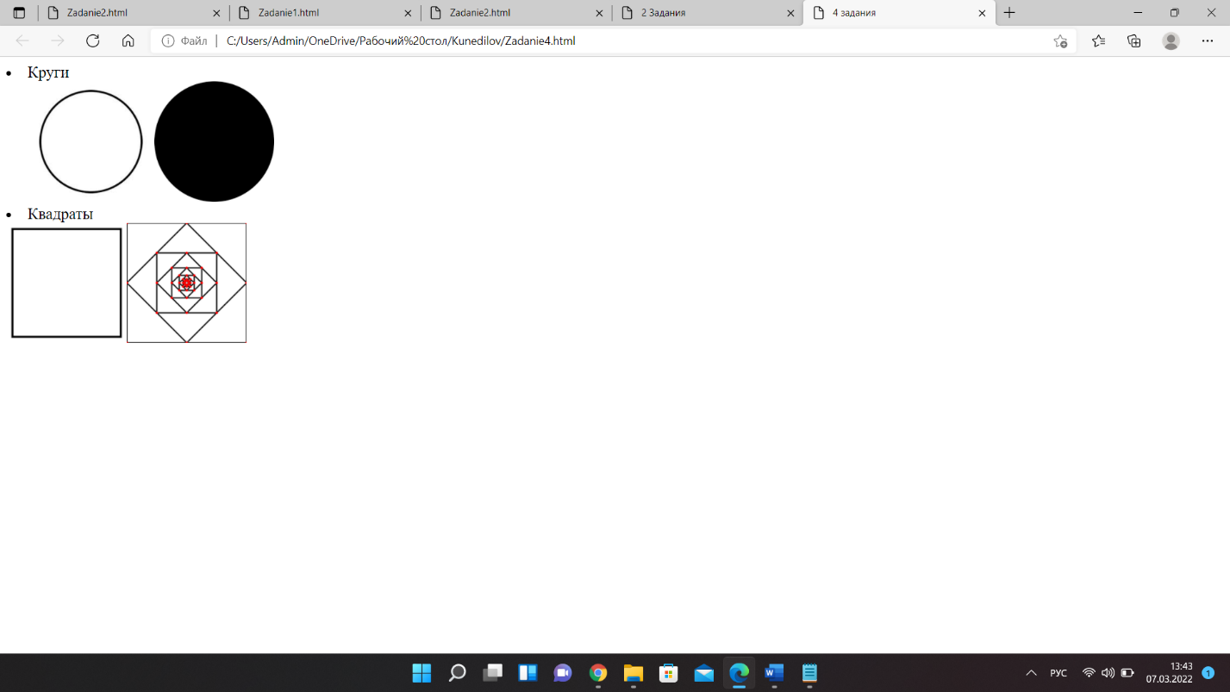

Задание 5

<DOCTYPE html>

<html lang="en">

<head>

<meta charset="UTF-8"/>

<meta http-equiv="X-UA-Compatible" content="IE=Edge">

<meta name="viewport" content="width=device-width, initial-scale=1.0">

<title>Bakhytzhan</title>

<link rel="stylesheet" href="cssZadanie5.css" type="text/css">

</head>

<body>

<div class="block1">

<input type="text" class="text" placeholder="BAKHYTZHAN">

<input type="button" class="button" value="KUNEDILOV">

</div>

</br>

<div class="block2">

<input type="text" class="text_one" value="Bakhyzthan">

<input type="button" class="button_one" value="Kunedilov">

</div>

</body>

</html>

CSS документ

Style.css

body {

margin: 0;

}

.block1 {

float: left;

width: 250px;

}

.block2 {

float: right;

width: 250px;

}

.text {

padding: 10px 30px;

background-color: rgb(255, 0, 212);

font-family: 'Segoe UI', Tahoma, Geneva, Verdana, sans-serif;

font-size: x-large;

font-weight: 100;

text-align: left;

color: rgb(255, 255, 255);

border-radius: 10px;

border-color: rgb(182, 26, 182);

}

.button {

padding: 10px;

border-color: green;

border-radius: 20px;

margin: 10px 0px;

color: green;

}

.text_one {

padding: 15px 15px;

border-radius: 35px;

font-size: large;

border-color: indigo;

color: mediumturquoise;

}

.button_one {

margin: 20px 0px;

padding: 20px 10px;

border-color: olive;

font-size: 20px;

}

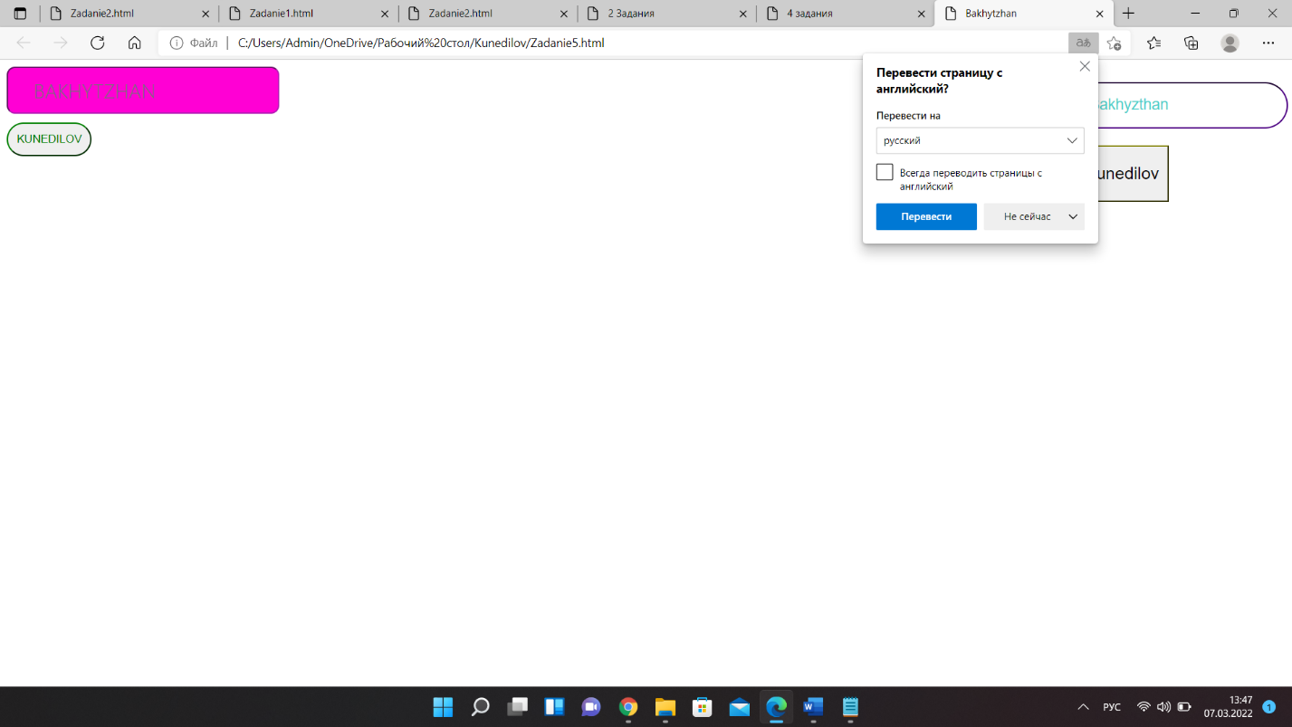

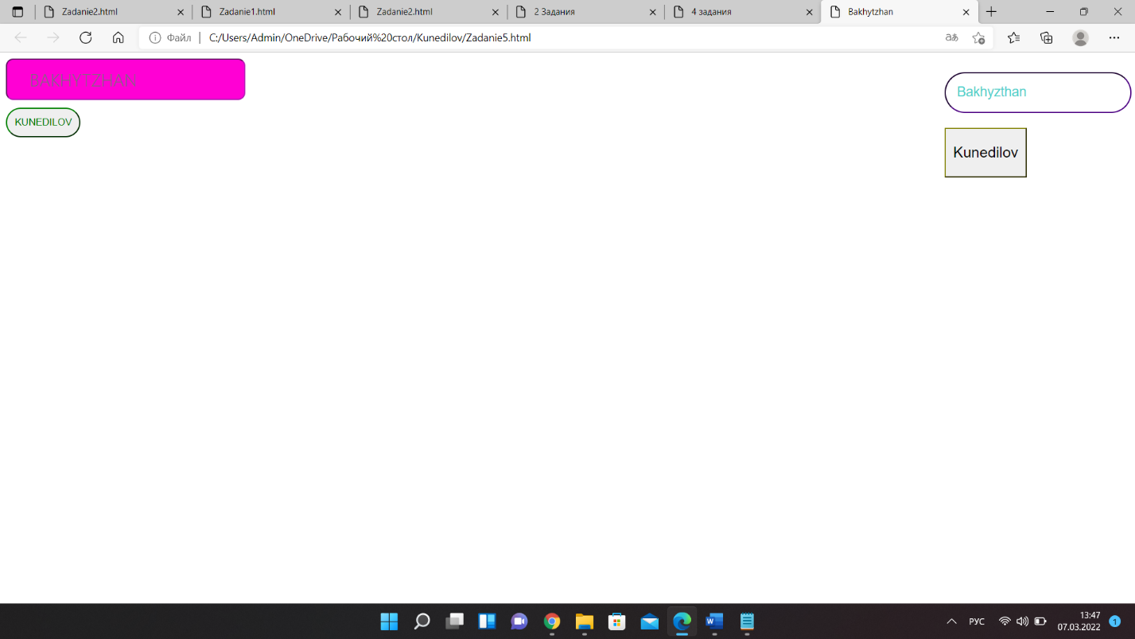

Задание 6

<DOCTYPE html>

<html>

<head>

<meta charset="UTF-8"/>

<title>BKunedilov</title>

<link href="cssZadanie6.css" rel="stylesheet" type="text/css">

</head>

<body>

<button class="but">Кабинет студента</button>

</body>

</html>

.but {

display: inline-block;

padding: 10px 8px;

font-size: 34px;

font-family: Arial, Helvetica, sans-serif;

font-weight: bold;

text-shadow: 0 1px slategray;

cursor: pointer;

text-align: center;

text-decoration: none;

outline: none;

color: #fff;

background-color: #ec654f;

border: none;

border-radius: 8px;

box-shadow:0 6px #d95a48;

}

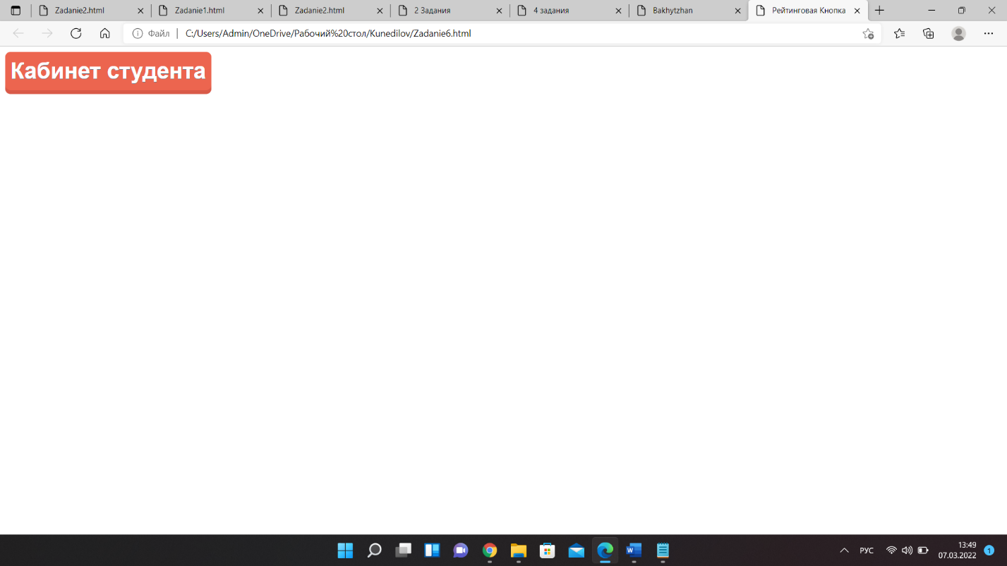

Задание 7

<DOCTYPE html>

<html>

<head>

<meta charset="UTF-8"/>

<title>BKunedilov</title>

<link href="cssZadanie7.css" rel="stylesheet" type="text/css">

</head>

<body>

<button class="but">Подписаться</button>

</body>

</html>

.but {

position: absolute;

padding: 25px 20px;

font-size: 35px;

font-weight: bold;

cursor: pointer;

text-align: center;

text-decoration: none;

outline: none;

color: #fff;

background-color: #a05b38;

border: none;

border-radius: 50px;

border-style: solid;

border-color: #773e21

}

